-- constraints ., restrictions on the values that

-- can be entered in the coulmns

-- We can add them at 2 points

-- 1. While creating table , create table

-- 2. After table is created , alter table

-- Type of constraints

-- 1. Primary Key

-- 2. Unique

-- 3. Not null

-- 4. Check

-- 5. Default

-- 6. Foreign Key

use practice

create table student (rollno int primary key,

name varchar(20) not null,

batch char(4) check (len(batch)=4 and

left(batch,1)='B'),

marks int check (marks between 0 and 100),

coach varchar(20) unique,

course varchar(10) default 'Basics')

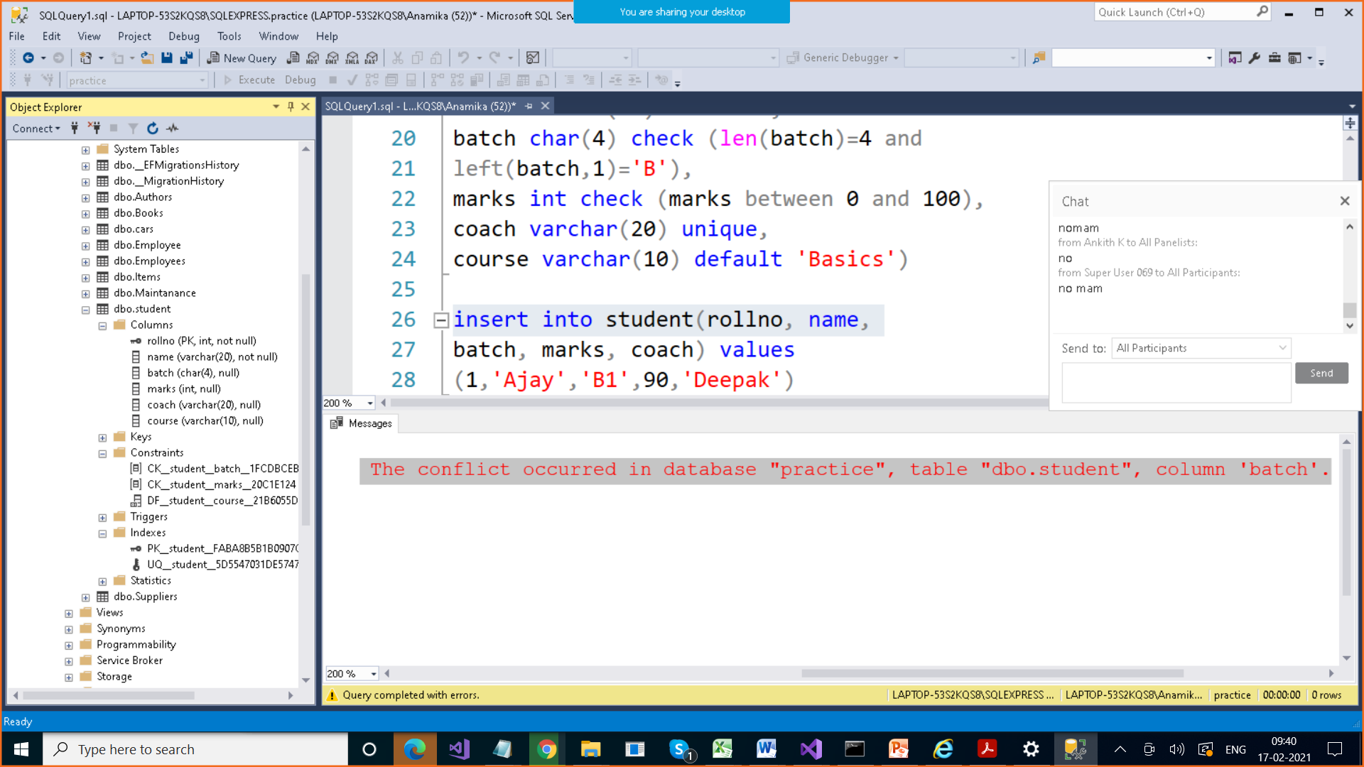

Constraints get name by default

When we added constraints like primary key , unique , we get 2 indexes

For Primary Key, we get Clustered Index

For Unique Key, we get NonClustered & Index

insert into student(rollno, name,

batch, marks, coach) values

(1,'Ajay','B001',90,'Deepak')

select * from student

insert into student(rollno, name,

batch, marks, coach,course) values

(2,'Deepak','B002',12,'Pawan','C#'),

(3,'Deepak','B003',23,null,'C#'),

(4,'Deepak','B001',12,'Farhan','Java'),

(5,'Deepak','B002',12,'Parul','C#'),

(6,'Deepak','B002',12,'Om','C#')

select * from student

select batch from student

select distinct(batch) from student

**Constraints with names**

create table student (rollno int constraint PK primary key,

name varchar(20) constraint namenotnull not null,

batch char(4) constraint batchcode check (len(batch)=4 and

left(batch,1)='B'),

marks int constraint markscheck check (marks between 0 and 100),

coach varchar(20) constraint coachck unique,

course varchar(10) constraint courseck default 'Basics')

**Table with no constraints**

create table student (rollno int,

name varchar(20),

batch char(4),

marks int ,

coach varchar(20) ,

course varchar(10) )

**How to add constraint after table is created**

**Alter table**

**We can not add Primary key to any column directly?**

**WHY???**

**Because all the columns are nullable , which means we have to first make those column non-nullable**

alter table student add constraint pk

primary key(rollno) > WILL GIVE ERROR

Msg8111, Level 16, State 1, Line 71

Cannot define PRIMARY KEY constraint on nullable column in table 'student'.

Msg 1750, Level 16, State 0, Line 71

Could not create constraint. See previous errors.

alter table student alter column rollno

int not null

alter table student add constraint pk

primary key(rollno)

alter table student alter column name

varchar(20) not null

alter table student add constraint

uk unique(coach)

<https://www.c-sharpcorner.com/UploadFile/f82e9a/enable-disable-constraints-in-sql-server/>

alter table student add constraint markscheck

check(marks > 20)

alter table student with nocheck add constraint markscheck

check(marks > 20)

Enable OR Disable constraints

**alter** **table** Student nocheck **constraint** CK__Student__Marks__29572725

**alter** **table** Student check **constraint** CK__Student__Marks__29572725

select * from student

create table fees (rollno int

references student(rollno) , amount int)

With Foreign key , we have two options

* On delete set null
* On delete cascade
* On update set null
* On update cascade

create table fees (rollno int

references student(rollno) on delete set null , amount int)

create table fees (rollno int

references student(rollno) on delete cascade , amount int)